**Methods**

**Sample and Data**

text

**Measures**

***Exposure and Engagement***

Prior literature suggests that news exposure has both ‘trait-like’ and ‘state-like’ properties (Weeks & Lane, 2020), and we included both kinds of indicators in our study. On the trait-like side, *total exposure* to political information was measured with six questionnaire items asking respondents how often in the past week they have encountered the following types of information (0 = *Never* and 4 = *Several times a day*): information critical of a candidate they support; information critical of a candidate they oppose; information supportive of a candidate they support; information supportive of a candidate they oppose; information that disagrees with their political views; and information that agrees with their political views (c.f., LANE). These items were averaged for each respondent, and the resulting scale is reliable (Cronbach’s alpha = .XX). The variable has a mean of 1.8 (*SD* = 1.3).

It is important to clarify whether exposure was incidental (Nanz & Matthes, in press). Therefore, immediately after answering the above battery of questions, respondents were asked a follow-up question: “On social media, some people intentionally search for news or political information, but others come across such information accidentally. What about you?” (0 = *Always intentionally* and 4 = *Always accidentally*). To create a measure of *incidental exposure*, this item was multiplied by the total exposure scale, and then the square root was calculated to maintain the original 5-point metric. The variable has a mean of 1.5 (*SD* = 1.1).

The state-like measures centered on the embedded story stimuli, and this measurement strategy was borrowed from prior literature (Thorson et al., in press). Respondents were shown a screenshot of a story headline and header image scrubbed of organizational logos that could cue partisan information processing, and then told that the story “has been circulating on Facebook recently” (a true statement, see above for details). They were then asked whether they had seen the story on Facebook. A follow-up question asked whether they had seen it on some other social media platform, and answers to these two items were recoded so that 1 = *Exposed* and 0 = *Not exposed*. Approximately 42% of the sample reported *story exposure*.

Those respondents who reported exposure were asked a series of additional follow-up questions, from which our measures of *incidental exposure* and *engagement* are created. First, this subset of respondents was asked: “When you say the story, were you purposefully seeking information on this topic?” (1 = *Yes* and 0 = *No*; 54% of subset and 23% of full sample said yes). Next, they were asked: “When you saw the story, did you engage in any of the following activities?” (1 = *Yes* and 0 = *No*): click on the story; scan the headline of the story; read the entire story; seek out additional information about the topic; comment on the post; discuss the story; and share the story. Responses were summed for each respondent (Cronbach’s alpha = .XX; *Min*. = 0 and *Max*. = 7), and the variable has a mean of 3.5 (*SD* = 2.2). Additionally, a *high-effort engagement* variable was created to isolate those activities that relatively higher amounts of cognitive or behavioral effort, including information seeking, commenting, discussing, and sharing (Cronbach’s alpha = .XX; *Min*. = 0, *Max*. = 4, *M* = 1.5, *SD* = 1.5).

***News Involvement***

The study includes four indictors of involvement with news. First, the study measures respondents’ perceptions of *social media as news source* (Weeks & Lane, 2020) by asking them which choice best describes their “reason for accessing [their] social media accounts”: to follow news and public affairs information; for some other reason; do not think very much about the reason. This three-level factor was recoded into a binary variable (1 = *News source* and 0 = *Not news source*). A little more than one-third of the sample (35%) views social media as a news source. Second, the study measures *self-reported interest* with a three-item scale. Questions asked respondents how interested they are (1 = *Not at all interested* and 5 = *Very interested*) in news, politics, and local community. These three items were averaged for each respondent (Cronbach’s alpha = .XX) and the variable has a mean of 3.5 (*SD* = 1.0). Third, the measures the extent which respondents *follow accounts for news* with a three-item scale. Items ask how often respondents follow accounts on social media because they are interested in what they post about news or current affairs, politics, and community events (1 = *Never* and 5 = *Very Frequently*). These three items were averaged for each respondent (Cronbach’s alpha = .XX), and the scale has a mean of 2.7 (*SD* = 1.2). Finally, we measured *algorithmic categorization* using a technique pioneered by Thorson and colleagues (2021). With the aim of obtaining an observable indicator of Facebook’s classification algorithm, we asked respondents at the end of the survey to open a web browser, navigate to the Settings menu of their Facebook accounts, and locate their Ad Interests section. We then asked them whether they saw the following categories included in their interests: (a) politics; (b) news or specific news organizations (e.g., the *New York Times*); or (c) neither. We coded this item into a binary variable (1 = *News or politics* and 0 = *Neither*). A little less than half (41%) of the sample was categorized as interested in news or politics.

C. Covariates

Prior research has shown that social networks structures are predictors of incidental exposure, and they also related to news involvement (Barnidge & Xenos, 2021). Therefore, it is important to include indicators of social network structures as covariates in the analysis, and we included four such variables. First, network size was measured by asking respondents how many people or accounts they are “friends with,” “follow,” or “subscribe to” on six social media platforms (1 = *None* and 7 = *2,001 or more*). Respondents’ answers to these items were averaged to create a scale (Cronbach’s alpha = .XX), which was then unobtrusively logged to correct for skew (*Min*. = 0 and *Max*. = 1.9). The final variable has a mean of 0.7 (*SD* = 0.5). Second, a structural measure of *network diversity* was borrowed directly from prior literature (Hampton et al., 2011). The measure uses a standardized list of 22 occupations and asks respondents whether they are connected someone on Facebook who belongs to each (1 = *Yes* and 0 = *No*). An averaged scale was created from these items (Cronbach’s alpha = .XX) , which has mean of 0.3 (*SD* = 0.3).

3. Group activity: 8 items correspond to different types of groups, discuss news or related topics, past month on Facebook; binary measure summed; logged scale 0-2.1, M = 0.5, SD = 0.6

4. Social news curation: 5 items, how much of friends posts about topics: election, politics or current affairs, social or community issues, racial or social justice issues, COvID; scale 1 = none at all-5 = almost all, averaged items; M = 2.9, SD = 1.1

D. Controls

1. Age: scale 1=18-24-7=85 or older, M = 3.0, SD = 1.6

2. Gender: 51%

3. Race: 40%

4. education: scale 1=some high school-7=post-graduate degree, M = 4.5, SD = 1.8

5. Income: scale 1=Less than $15,000-8=more than $150,000, M = 4.7, SD = 2.3

6. Ideology: 11-point scale LR scale -5=very liberal-5=very conservative, M = 0.2, SD = 3.0

7. Party Id: 3 items ANES, id (generally speaking), strength (how strong), lean (closer to …), scale -3=strong dem-3=strong rep, M = -0.3, SD = 2.0

8. Frequency of social media use: single item, prior literature, average time per day actively using social media (list) scale 1 = less than 10 minutes-6 = more than three hours, M = 3.5, SD = 1.6

III. Analysis

A. LCA

B. MLM

C. MLM

|  |  |  |  |  |  |  |  |  |  |  |  |  |
| --- | --- | --- | --- | --- | --- | --- | --- | --- | --- | --- | --- | --- |
| Table 1  *Group Differences in Incidental Exposure and Total/Story Exposure among the Involvement Groups* | | | | | | | | | | | | |
|  | Incidental Exposure | | | | | | Total Exposure | | | Story Exposure | | |
|  | Trait-Like Variable | | | State-Like Variable | | | Trait-Like Variable | | | State-Like Variable | | |
| **Fixed Effects** | β | | *SE* | β | | *SE* | β | | *SE* | β | | *SE* |
| Intercept | -0.15 | | 0.11 | -2.44*** | | 0.26 | -0.34** | | 0.12 | -2.06*** | | 0.21 |
| Involvement (Medium:Low) | -0.09 | | 0.06 | 0.34** | | 0.12 | 0.29*** | | 0.06 | 0.52*** | | 0.10 |
| Involvement (High:Low) | -1.07*** | | 0.09 | 0.22 | | 0.21 | 0.44*** | | 0.09 | 0.58*** | | 0.15 |
| Age | -0.07*** | | 0.02 | 0.09 | | 0.04 | 0.08*** | | 0.02 | 0.00 | | 0.03 |
| Gender (1 = Female) | 0.03 | | 0.05 | -0.16 | | 0.10 | -0.07 | | 0.04 | -0.23** | | 0.08 |
| Race (1 = Person of Color) | -0.13** | | 0.05 | -0.08 | | 0.10 | -0.20*** | | 0.04 | -0.01 | | 0.02 |
| Education | 0.05** | | 0.02 | 0.00 | | 0.03 | 0.04** | | 0.01 | 0.02 | | 0.02 |
| Income | 0.00 | | 0.01 | -0.04 | | 0.03 | 0.00 | | 0.01 | -0.03 | | 0.02 |
| Ideology (+ Conservative) | -0.03** | | 0.01 | -0.02 | | 0.02 | -0.02** | | 0.01 | 0.01 | | 0.01 |
| Party Identity (+ Republican) | 0.05*** | | 0.01 | 0.01 | | 0.03 | 0.04*** | | 0.01 | -0.00 | | 0.01 |
| Frequency of Social Media Use | 0.06*** | | 0.01 | 0.06 | | 0.03 | 0.05*** | | 0.01 | -0.01 | | 0.02 |
| Network Size | -0.19*** | | 0.07 | -0.14 | | 0.15 | 0.22*** | | 0.07 | 0.16 | | 0.11 |
| Network Diversity | 0.19 | | 0.10 | -0.03 | | 0.22 | 0.22* | | 0.10 | 0.33* | | 0.15 |
| Group Activity | 0.22*** | | 0.05 | 0.07 | | 0.10 | 0.24*** | | 0.04 | 0.09 | | 0.07 |
| Social News Curation | 0.41*** | | 0.03 | 0.07 | | 0.06 | 0.48*** | | 0.03 | 0.22*** | | 0.05 |
| Incidental Exposure (Trait-Like) |  | |  | 0.25*** | | 0.05 |  | |  | 0.02 | | 0.04 |
| **Random Effects** | *Var.* | | *SD* | *Var.* | | *SD* | *Var.* | | *SD* | *Var.* | | *SD* |
| InterceptFrame | 0.01 | | 0.08 | 0.04 | | 0.20 | 0.01 | | 0.10 | 0.04 | | 0.20 |
| Residual | 0.95 | | 0.98 | 1.96 | | 1.40 | 0.86 | | 0.93 | 1.29 | | 1.14 |
| **Fit Statistics** |  |  | |  |  | |  |  | |  |  | |
| ICC | .01 | | | .02 | | | .01 | | | .03 | | |
| LL | -3,076.72 | | | -1,045.05 | | | -2,975.84 | | | -1,340.59 | | |
| Pseudo-*R*2 | .21 | | | .12 | | | .51 | | | .12 | | |
| *Note*: Cell entries are parameter estimates from multilevel models with random intercepts. Linear models are used for trait-like variables, and quasi-binomial models are used for state-like variables. Data are weighted by education and income. *N* = 2,008. Groups = 17. | | | | | | | | | | | | |

|  |  |  |  |  |  |  |
| --- | --- | --- | --- | --- | --- | --- |
| Table 2  *Conditional Effects of Incidental Exposure on Story Engagement* | | | |  |  | |
|  | Engagement | | High-Effort Engagement | | | | |
| **Fixed Effects** | β | *SE* | β | | | *SE* | |
| Intercept | 2.65*** | 0.42 | 1.21*** | | | 0.27 | |
| Incidental Exposure (Trait-Like) | -0.14*** | 0.06 | -0.10** | | | 0.04 | |
| Incidental Exposure (State-Like) | -2.06*** | 0.31 | -1.16*** | | | 0.20 | |
| Involvement (Medium:Low) | 0.11* | 0.72 | -0.10 | | | 0.20 | |
| Involvement (High:Low) | -0.50 | 0.35 | 0.31 | | | 0.23 | |
| Age | 0.01 | 0.05 | -0.03 | | | 0.03 | |
| Gender (1 = Female) | -0.28* | 0.12 | -0.20* | | | 0.08 | |
| Race (1 = Person of Color) | 0.25*** | 0.13 | 0.07 | | | 0.08 | |
| Education | -0.02 | 0.04 | -0.03 | | | 0.03 | |
| Income | 0.02 | 0.03 | 0.01 | | | 0.02 | |
| Ideology (+ Conservative) | 0.03 | 0.02 | 0.03* | | | 0.01 | |
| Party Identity (+ Republican) | -0.06 | 0.03 | -0.04* | | | 0.02 | |
| Frequency of Social Media Use | 0.00 | 0.04 | 0.01 | | | 0.03 | |
| Network Size | 0.19 | 0.17 | 0.27* | | | 0.11 | |
| Network Diversity | 0.68** | 0.24 | 0.38* | | | 0.16 | |
| Group Activity | 0.24* | 0.10 | 0.20** | | | 0.07 | |
| Social News Curation | 0.36*** | 0.08 | 0.19*** | | | 0.06 | |
| **Interactions** |  |  |  | | |  | |
| Incidental Exposure (State-Like) x Involvement (Medium:Low) | -0.71* | 0.34 | 0.30 | | | 0.22 | |
| Incidental Exposure (State-Like) x Involvement (High:Low) | -0.38 | 0.41 | -0.12 | | | 0.27 | |
| **Random Effects** | *Var*. | *SD* | *Var*. | | | *SD* | |
| InterceptFrame | 0.02 | 0.21 | 0.02 | | | 0.13 | |
| Residual | 2.67 | 1.51 | 1.15 | | | 1.07 | |
| **Fit Statistics** |  |  |  | | |  | |
| ICC | .01 | | .02 | | | | |
| LL | -1,613.46 | | -1285.40 | | | | |
| Pseudo-*R*2 | .46 | | 0.47 | | | | |
| *Note*: Cell entries are parameter estimates from a multilevel model with random intercepts. Data are weighted by education and income. Analysis uses subset of respondents who report exposure to story. *N* = 842. Groups = 17. | | | | |  | |

Figure 1

*Differences among involvement groups in news exposure.*

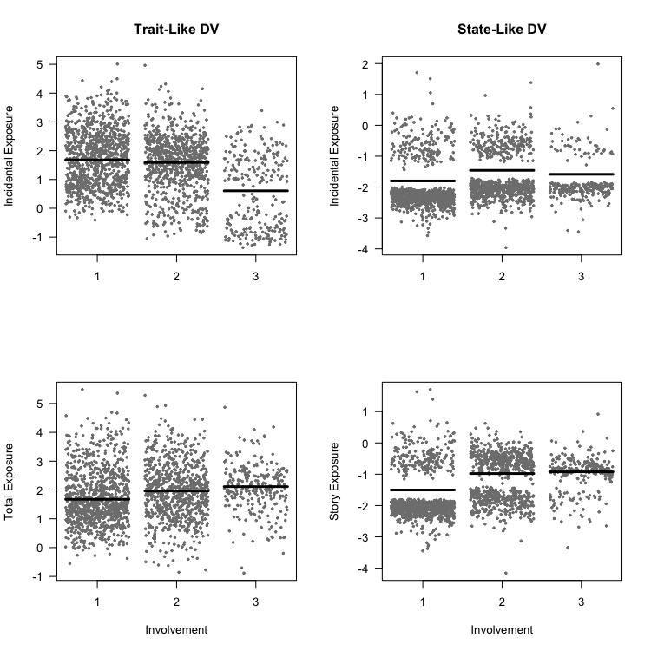

Figure 2

*Differences between incidentally and purposefully exposed in news engagement by level of involvement.*

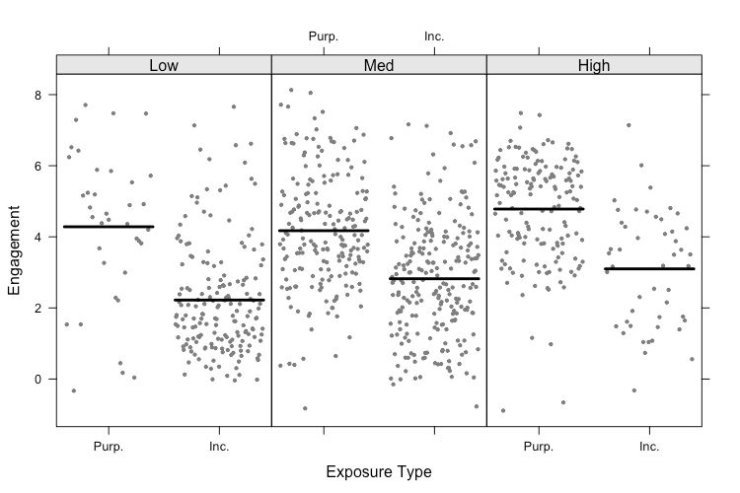

Figure 3

*Differences between incidentally and purposefully exposed in news engagement by level of involvement.*

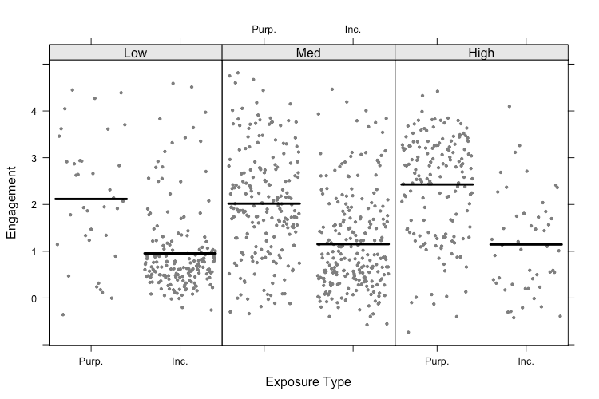

Appendices

|  |  |  |  |  |
| --- | --- | --- | --- | --- |
| Table A1  *Correlations Among Variables Used in Latent Class Analysis* | | | | |
| Variable | 1. | 2. | 3. | 4. |
| 1. Social Media as News Source (1 = Yes) | 1.00 |  |  |  |
| 2. Self-Reported Interest | .34 | 1.00 |  |  |
| 3. Follow Accounts for News | .52 | .50 | 1.00 |  |
| 4. Algorithmic Categorization (1 = Interested) | .36 | .34 | .46 | 1.00 |
| *Note*: Cell entries are Pearson’s correlation coefficients (*r*). *N* = 2,008 | | | | |

|  |  |  |  |  |
| --- | --- | --- | --- | --- |
| Table A2  *Model Fit Statistics for Models with Varying Number of Latent Classes* | | | | |
| Model | AIC | BIC | *G*2 | χ2 |
| 2 Classes | 16,036.27 | 16,153.98 | 398.90 | 409.10 |
| **3 Classes** | **15,810.00** | **15,989.35** | **150.63** | **149.52** |
| 4 Classes | 15,759.35 | 16,000.36 | 77.98 | 82.96 |
| 5 Classes | 15,758.16 | 16,060.83 | 54.79 | 53.95 |
| *Note*: BIC was the primary criterion for model selection. *N* = 2,008. | | | | |

|  |  |  |
| --- | --- | --- |
| Table A3  *Predicted and Observed Latent Class Membership* | | |
| Latent Class | Predicted | Observed | |
| 1: Low Involvement (*n* = 968) | .48 | .48 | |
| 2: Medium Involvement (*n* = 788) | .39 | .38 | |
| 3: High Involvement (*n* = 252) | .13 | .15 | |
| *Note*: Cell entries are predicted probabilities and observed proportions obtained from a latent class analysis (LCA) model. Column totals may not equal 1 due to rounding. *N* = 2,008. | | |

Figure A1

*Group Distributions on Manifest Variables from Latent Class Analysis*

